# BUS RESERVATION SYSTEM

**ABSTRACT**

The Bus Reservation System is a cutting-edge software solution designed to modernize and optimize the process of bus ticket booking and management. It serves as a comprehensive tool for passengers seeking a streamlined ticketing experience and for administrators managing bus operations. For passengers, the system provides an intuitive web-based interface where users can easily search for available buses based on various criteria such as destination, date, and time. It offers a seamless booking experience, complete with secure payment options and real-time seat availability updates. Passengers can also manage their bookings with features that allow for modifications, cancellations, and viewing booking history, thus enhancing user convenience and satisfaction. On the administrative side, the system delivers a suite of powerful tools for managing bus routes, schedules, and reservations. Administrators can effortlessly create and update routes, monitor booking trends, and generate detailed reports on system usage and revenue. This functionality helps in optimizing bus schedules and improving overall operational efficiency. The backend of the system is powered by a robust relational database that ensures reliable data management and integrity. Built using modern technologies such as HTML, CSS, JavaScript, and server-side languages like Java, Python, or PHP, the system is designed for high performance and scalability. Security is a priority, with features such as encryption and secures payment gateways safeguarding user data and financial transactions. Additional features of the system include automated ticketing processes that reduce manual errors and administrative workload. Real-time updates ensure that users and administrators have access to the most current information, improving decision-making and operational responsiveness. The system is also designed with scalability in mind, capable of handling increasing volumes of users and bookings as bus services expand. Its flexibility allows for easy integration with other systems and the addition of new features, ensuring long-term adaptability and growth.

# BUS RESERVATION SYSTEM

**CHAPTER 1**

**INTRODUCTION**

**1.1 Bus Reservation System**

The **Bus Reservation System** is a state-of-the-art software solution designed to revolutionize the traditional bus ticketing and reservation process. This system addresses the limitations of manual ticketing and outdated methods by providing a streamlined, digital approach to managing bus reservations, ticketing, and operational tasks. By replacing physical ticket racks and manual record-keeping with a sophisticated electronic system, the project aims to enhance efficiency, accuracy, and convenience for both passengers and bus operators.

Traditionally, bus ticketing involved the use of physical tickets, manual fare collection, and cumbersome paperwork, which not only increased the chances of errors but also led to inefficiencies in managing reservations and schedules. The introduction of an electronic bus reservation system addresses these challenges by offering a user-friendly platform for passengers to book tickets online, view schedules, and manage their travel plans from any location. This digital transformation eliminates the need for physical ticket counters and manual ticket handling, thereby reducing operational overhead and enhancing user experience.

The system provides passengers with a seamless booking experience through a responsive web interface, allowing them to search for available buses, select their preferred seats, and make secure payments online. This automation ensures real-time updates on seat availability and booking confirmations, leading to improved accuracy and reduced manual errors. Additionally, passengers can access their booking history, modify or cancel reservations, and receive instant notifications about their trips.

**This project is modularized as the following:**

* Management of Route
* Trip Details
* Bus Details
* Bus Ticketing

**1. Management of Routes**

This module include information about how we can Manage the routes for a particular bus services so In the case of Route management module we must know the details about route number, number of stops ,fare stages and running time of the particular bus more over we want to manipulate and stored these information successfully.

**2. Trip information**

Each journey is identified as a trip. Each ticket must contain the trip no so that calculation of passenger can be done easily. Here in this section we want to know start time and route no of the bus this information can be manipulate and stored successfully.

**3. Bus Detail**

In this module all bus details are stored and manipulated, in bus detail module contains minimum charge, type, depot, fare increment, bus number, and passenger’s states (child or adult) are manipulate and stored.

4. **Bus Stops**

Bus Stops module includes information about what are the main bus stops of a particular bus. This module connected to the route of the bus and it is used to store stop number, stop name and fare stages and Route number

**5. Bus Ticketing**

Ticketing is the most important module in this Project which uses all the tables together and calculates fare for the passengers. Venting the tickets is done using the route number, bus type, beginning stop, end stop, ticket number, persons(Adult/child)rate, date and time also we want to print the all these information. In order to do the calculation data has to be pulled out from stops, bus, trip and route. Number of passengers & the states are entered by the Venter and to produce the tickets.

CHAPTER 2

**SYSTEM STUDY AND ANALYSIS**

**2.1 INTRODUCTION**

System analysis is a process of gathering and interpreting facts, diagnosing problems and the information to recommend improvements on the system. It is a problem solving activity that requires intensive communication between the system users and system developers. System analysis or study is an important phase of any system development process. The system is studied to the minutest detail and analyzed. The system analyst plays the role of the interrogator and dwells deep into the working of the present system. The system is viewed as a whole and the input to the system are identified. The outputs from the organizations are traced to the various processes. System analysis is concerned with becoming aware of the problem, identifying the relevant and decisional variables, analyzing and synthesizing the various factors and determining an optimal or at least a satisfactory solution or program of action.

      A detailed study of the process must be made by various techniques like interviews, questionnaires etc. The data collected by these sources must be scrutinized to arrive to a conclusion. The conclusion is an understanding of how the system functions. This system is called the existing system. Now the existing system is subjected to close study and problem areas are identified. The designer now functions as a problem solver and tries to sort out the difficulties that the enterprise faces. The solutions are given as proposals. The proposal is then weighed with the existing system analytically and the best one is selected. The proposal is presented to the user for an endorsement by the user. The proposal is reviewed on user request and suitable changes are made. This is loop that ends as soon as the user is satisfied with proposal.

      Preliminary study is the process of gathering and interpreting facts, using the information for further studies on the system. Preliminary study is problem solving activity that requires intensive communication between the system users and system developers. It does various feasibility studies. In these studies a rough figure of the system activities can be obtained, from which the decision about the strategies to be followed for effective system study and analysis can be taken.

   Here in the project E-Ticketing, a detailed study of existing system is carried along with all the steps in system analysis. An idea for creating a better project was carried and the next steps were followed.

**2.2 FEASIBILITY STUDY**

An important outcome of the preliminary investigation is the determination that the system requested is feasible. Feasibility study is carried out to select the best system that meets the performance requirements.

Feasibility study is both necessary and prudent to evaluate the feasibility of the project at the earliest possible time. It involves preliminary investigation of the project and examines whether the designed system will be useful to the organization. Months or years of effort, thousand for millions of money and untold professional embarrassment can be averted if an in-conceived system is recognized early in the definition phase.

The different types of feasibility are: Technical feasibility, Operational feasibility, Economical feasibility.

**2.2.1 Technical feasibility**

Technical Feasibility deals with the hardware as well as software requirements. Technology is not a constraint to type system development. We have to find out whether the necessary technology, the proposed equipments have the capacity to hold the data, which is used in the project, should be checked to carryout this technical feasibility.

The technical feasibility issues usually raised during the feasibility stage of investigation includes these

* This software is running in windows 2000 Operating System, which can be easily installed.
* The hardware required is Pentium based server.
* The system can be expanded.

**2.2.2 Behavioral Feasibility**

This feasibility test asks if the system will work when it is developed and installed.

Operational feasibility in this project:

* + - The proposed system offers greater level of user-friendliness.
    - The proposed system produces best results and gives high performance. It can be implemented easily .So this project is operationally feasible.

**2.2.3 Economical feasibility**

Economical Feasibility deals about the economical impact faced by the organization to implement a new system. Financial benefits must equal or exceed the costs. The cost of conducting a full system, including software and hardware cost for the class of application being considered should be evaluated.

Economic Feasibility in this project:

* + - The cost to conduct a full system investigation is possible.
    - There is no additional manpower requirement.
    - There is no additional cost involved in maintaining the proposed system.

**CHAPTER 3**

**SYSTEM STUDY**

**3.1 EXISTING SYSTEM**

Existing system refers to the system that is being followed till now. The existing system requires more computational time, more manual calculations, and the complexity involved in Selection of features is high. The other disadvantages are lack of security of data, Deficiency of Data accuracy, Time consuming etc. To avoid all these limitations and make the working more accurately the system needs to be computerized.    Here in the Electronic bus ticketing, a detailed study of existing system is carried along with all the steps in system analysis.

**3.2 Draw backs of existing system.**

      Here in the Electronic bus ticketing, a detailed study of existing system is carried along with all the steps in system analysis. An idea for creating a better project was carried and the next steps were followed.

* Lack of security of data.
* More man power.
* Time consuming.
* Consumes large volume of pare work.
* Needs manual calculations.
* No direct role for the higher officials.
* Damage of machines due to lack of attention.

To avoid all these limitations and make the working more accurately the system needs to be computerized.

**3.3 PROPOSED SYSTEM**

The aim of proposed system is to develop a system of improved facilities. The proposed system can overcome all the limitations of the existing system. The system provides proper security and reduces the manual work. The existing system has several disadvantages and many more difficulties to work well. The proposed system tries to eliminate or reduce these difficulties up to some extent. The proposed system will help the user to reduce the workload and mental conflict. The proposed system helps the user to work user friendly and he can easily do his jobs without time lagging.

**3.4 Advantages of Proposed System**

The system is very simple in design and to implement. The system requires very low system resources and the system will work in almost all configurations. It has got following features

* Ensure data accuracy.
* Minimize manual data entry.
* Minimum time needed for the various processing
* Greater efficiency
* Better Service
* Minimum time required
* The ticket machines would help prevent loss on account of malpractice
* It would also help in providing adequate data to the corporation, particularly with regard to boarding of passengers from fare stages and important points
* This would help the corporation prepare and organize its schedules more efficiently on the basis of traffic demand.
* It would provide data on concessions given to various sections.
* Another additional feature is that the data in the ticket machine could be fed into the computer.

**CHAPTER 4**

**SYSTEM SPECIFICATION**

**4.1 Hardware Specification**

Processor : Intel Pentium IV 2.4 GHZ or above

Clock speed : 500 MHZ

System bus : 32 bits

RAM : 256MB of RAM

HDD : 40 GB or higher

Monitor : SVGA COLOR

Keyboard : 108 keys

Mouse : 2 button mouse

**4.2** **Software Specification**

OS : MS WINDOWS XP SP2

Front End : HTML,CSS,JAVA SCRIPT

Back End : JAVA,MYSQL

**CHAPTER 5**

**SYSTEM DESIGN**

**SYSTEM ARCHITECTURE**

A system architecture diagram abstracts the relationships, restrictions, and boundaries between components of a software system. It's a crucial tool that provides a comprehensive overview of the software system's physical deployment and development roadmap. An architectural diagram must perform a variety of task

|



Register

Login

Add bus



Register

Login

Bus Details

Search bus

Book Bus

Payment

Histroy

**UML DIAGRAMS**

Unified Modeling Language (UML) is a standardized visual modeling language widely used in software engineering to design, document, and communicate about software systems. Developed by the Object Management Group (OMG), UML provides a set of graphical notations that facilitate the representation of various aspects of a software system. UML diagrams serve as a common language for software developers, analysts, and other stakeholders, enabling them to visualize and understand the structure, behavior, and interactions within a system. With a diverse set of diagram types, such as Use Case Diagrams, Class Diagrams, Sequence Diagrams, and Deployment Diagrams, UML offers a comprehensive approach to modeling complex software systems at different levels of abstraction. Whether depicting the dynamic behavior of a system through sequence diagrams or illustrating its static structure with class diagrams, UML plays a crucial role in fostering clear communication and collaboration among the diverse set of professionals involved in the software development process.

**Use Case Diagrams** provide a high-level view of a system by illustrating the interactions between external actors (such as users or other systems) and the system itself. Actors are depicted as entities outside the system, and use cases represent specific functionalities or actions the system can perform. This type of diagram is instrumental in capturing and visualizing the user's perspective, helping to identify system functionalities and their relationships with external entities.



**Class Diagrams**

focus on the static structure of a system, offering a detailed representation of the classes within it, along with their attributes, methods, and associations. Classes are depicted as rectangles, and relationships between them, such as associations, generalizations, or aggregations, are illustrated with lines. Class Diagrams provide a foundation for understanding the architecture of a system, emphasizing its static elements and their relationships.

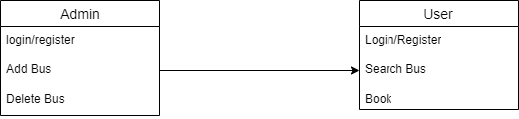

**Sequence Diagrams**

portray the dynamic behavior of a system by showcasing the interactions and messages exchanged between objects over time. Objects, represented as lifelines, participate in sequences of activities, and messages denote the flow of communication. Sequence Diagrams are invaluable for understanding the chronological order of events and collaborations between objects during the execution of a particular scenario, aiding in the visualization of system behavior.

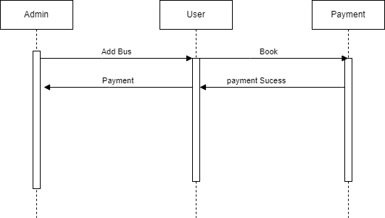

**Collaboration Diagram**

User

Login

Bus Details

Search Bus

Book

payment

**ACTIVITY DIAGRAM**

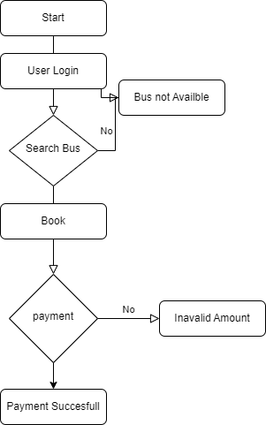

**Data Flow Diagram (DFD)**

A Data Flow Diagram (DFD) is a graphical representation that illustrates how data moves within a system. It consists of processes, data stores, data flows, and external entities. Processes represent activities or transformations, data stores signify where data is stored, data flows depict the movement of data between elements, and external entities are sources or destinations of data. DFDs provide a clear visualization of the data flow within a system, aiding in the understanding of information processes and interactions. They are particularly useful in system analysis and design, helping to identify data sources, processing steps, and data destinations in a concise and intuitive manner.

User Input

Booking

Payment Unsuccesfull

Payment Succesfull

**CHAPTER 6**

**SOFTWARE DESCRIPTION**

**Java Technology**

Java technology is both a programming language and a platform.

**The Java Programming Language**

The Java programming language is a high-level language that can be characterized by all of the following buzzwords:

* Simple
* Architecture neutral
* Object oriented
* Portable
* Distributed
* High performance
* Interpreted
* Multithreaded
* Robust
* Dynamic
* Secure

With most programming languages, you either compile or interpret a program so that you can run it on your computer. The Java programming language is unusual in that a program is both compiled and interpreted. With the compiler, first you translate a program into an intermediate language called Java byte codes —the platform-independent codes interpreted by the interpreter on the Java platform. The interpreter parses and runs each Java byte code instruction on the computer. Compilation happens just once; interpretation occurs each time the program is executed. The following figure illustrates how this works.

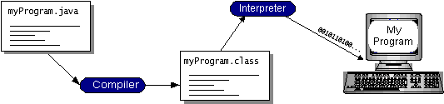

You can think of Java byte codes as the machine code instructions for the Java Virtual Machine (Java VM). Every Java interpreter, whether it’s a development tool or a Web browser that can run applets, is an implementation of the Java VM. Java byte codes help make “write once, run anywhere” possible. You can compile your program into byte codes on any platform that has a Java compiler. The byte codes can then be run on any implementation of the Java VM. That means that as long as a computer has a Java VM, the same program written in the Java programming language can run on Windows 2000, a Solaris workstation, or on an iMac.

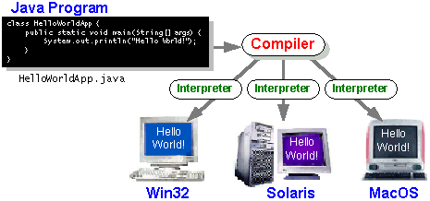

**The Java Platform**

A platform is the hardware or software environment in which a program runs. We’ve already mentioned some of the most popular platforms like Windows 2000, Linux, Solaris, and MacOS. Most platforms can be described as a combination of the operating system and hardware. The Java platform differs from most other platforms in that it’s a software-only platform that runs on top of other hardware-based platforms.

The Java platform has two components:

* The Java Virtual Machine (Java VM)
* The Java Application Programming Interface (Java API)

You’ve already been introduced to the Java VM. It’s the base for the Java platform and is ported onto various hardware-based platforms.

The Java API is a large collection of ready-made software components that provide many useful capabilities, such as graphical user interface (GUI) widgets. The Java API is grouped into libraries of related classes and interfaces; these libraries are known as packages. The next section, What Can Java Technology Do? Highlights what functionality some of the packages in the Java API provide.

The following figure depicts a program that’s running on the Java platform. As the figure shows, the Java API and the virtual machine insulate the program from the hardware.

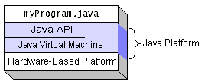

Native code is code that after you compile it, the compiled code runs on a specific hardware platform. As a platform-independent environment, the Java platform can be a bit slower than native code. However, smart compilers, well-tuned interpreters, and just-in-time byte code compilers can bring performance close to that of native code without threatening portability.

**What Can Java Technology Do?**

The most common types of programs written in the Java programming language are applets and applications. If you’ve surfed the Web, you’re probably already familiar with applets. An applet is a program that adheres to certain conventions that allow it to run within a Java-enabled browser.

However, the Java programming language is not just for writing cute, entertaining applets for the Web. The general-purpose, high-level Java programming language is also a powerful software platform. Using the generous API, you can write many types of programs.

An application is a standalone program that runs directly on the Java platform. A special kind of application known as a *server* serves and supports clients on a network. Examples of servers are Web servers, proxy servers, mail servers, and print servers. Another specialized program is a *servlet*. A servlet can almost be thought of as an applet that runs on the server side. Java Servlets are a popular choice for building interactive web applications, replacing the use of CGI scripts. Servlets are similar to applets in that they are runtime extensions of applications. Instead of working in browsers, though, servlets run within Java Web servers, configuring or tailoring the server.

How does the API support all these kinds of programs? It does so with packages of software components that provides a wide range of functionality. Every full implementation of the Java platform gives you the following features:

* **The essentials**: Objects, strings, threads, numbers, input and output, data structures, system properties, date and time, and so on.
* **Applets**: The set of conventions used by applets.
* **Networking**: URLs, TCP (Transmission Control Protocol), UDP (User Data gram Protocol) sockets, and IP (Internet Protocol) addresses.
* **Internationalization**: Help for writing programs that can be localized for users worldwide. Programs can automatically adapt to specific locales and be displayed in the appropriate language.
* **Security**: Both low level and high level, including electronic signatures, public and private key management, access control, and certificates.
* **Software components**: Known as JavaBeansTM, can plug into existing component architectures.
* **Object serialization**: Allows lightweight persistence and communication via Remote Method Invocation (RMI).
* **Java Database Connectivity (JDBCTM)**: Provides uniform access to a wide range of relational databases.

The Java platform also has APIs for 2D and 3D graphics, accessibility, servers, collaboration, telephony, speech, animation, and more. The following figure depicts what is included in the Java 2 SDK.

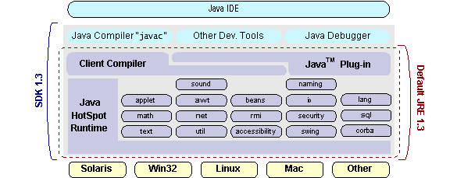

How Will Java Technology Change My Life?

We can’t promise you fame, fortune, or even a job if you learn the Java programming language. Still, it is likely to make your programs better and requires less effort than other languages. We believe that Java technology will help you do the following:

* **Get started quickly**: Although the Java programming language is a powerful object-oriented language, it’s easy to learn, especially for programmers already familiar with C or C++.
* **Write less code**: Comparisons of program metrics (class counts, method counts, and so on) suggest that a program written in the Java programming language can be four times smaller than the same program in C++.
* **Write better code**: The Java programming language encourages good coding practices, and its garbage collection helps you avoid memory leaks. Its object orientation, its JavaBeans component architecture, and its wide-ranging, easily extendible API let you reuse other people’s tested code and introduce fewer bugs.
* **Develop programs more quickly**: Your development time may be as much as twice as fast versus writing the same program in C++. Why? You write fewer lines of code and it is a simpler programming language than C++.
* **Avoid platform dependencies with 100% Pure Java**: You can keep your program portable by avoiding the use of libraries written in other languages. The 100% Pure JavaTM Product Certification Program has a repository of historical process manuals, white papers, brochures, and similar materials online.
* **Write once, run anywhere**: Because 100% Pure Java programs are compiled into machine-independent byte codes, they run consistently on any Java platform.
* **Distribute software more easily**: You can upgrade applets easily from a central server. Applets take advantage of the feature of allowing new classes to be loaded “on the fly,” without recompiling the entire program.

**ODBC**

Microsoft Open Database Connectivity (ODBC) is a standard programming interface for application developers and database systems providers. Before ODBC became a de facto standard for Windows programs to interface with database systems, programmers had to use proprietary languages for each database they wanted to connect to. Now, ODBC has made the choice of the database system almost irrelevant from a coding perspective, which is as it should be. Application developers have much more important things to worry about than the syntax that is needed to port their program from one database to another when business needs suddenly change.

Through the ODBC Administrator in Control Panel, you can specify the particular database that is associated with a data source that an ODBC application program is written to use. Think of an ODBC data source as a door with a name on it. Each door will lead you to a particular database. For example, the data source named Sales Figures might be a SQL Server database, whereas the Accounts Payable data source could refer to an Access database. The physical database referred to by a data source can reside anywhere on the LAN.

The ODBC system files are not installed on your system by Windows 95. Rather, they are installed when you setup a separate database application, such as SQL Server Client or Visual Basic 4.0. When the ODBC icon is installed in Control Panel, it uses a file called ODBCINST.DLL. It is also possible to administer your ODBC data sources through a stand-alone program called ODBCADM.EXE. There is a 16-bit and a 32-bit version of this program and each maintains a separate list of ODBC data sources.

From a programming perspective, the beauty of ODBC is that the application can be written to use the same set of function calls to interface with any data source, regardless of the database vendor. The source code of the application doesn’t change whether it talks to Oracle or SQL Server. We only mention these two as an example. There are ODBC drivers available for several dozen popular database systems. Even Excel spreadsheets and plain text files can be turned into data sources. The operating system uses the Registry information written by ODBC Administrator to determine which low-level ODBC drivers are needed to talk to the data source (such as the interface to Oracle or SQL Server). The loading of the ODBC drivers is transparent to the ODBC application program. In a client/server environment, the ODBC API even handles many of the network issues for the application programmer.

The advantages of this scheme are so numerous that you are probably thinking there must be some catch. The only disadvantage of ODBC is that it isn’t as efficient as talking directly to the native database interface. ODBC has had many detractors make the charge that it is too slow. Microsoft has always claimed that the critical factor in performance is the quality of the driver software that is used. In our humble opinion, this is true. The availability of good ODBC drivers has improved a great deal recently. And anyway, the criticism about performance is somewhat analogous to those who said that compilers would never match the speed of pure assembly language. Maybe not, but the compiler (or ODBC) gives you the opportunity to write cleaner programs, which means you finish sooner. Meanwhile, computers get faster every year.

**JDBC**

In an effort to set an independent database standard API for Java; Sun Microsystems developed Java Database Connectivity, or JDBC. JDBC offers a generic SQL database access mechanism that provides a consistent interface to a variety of RDBMSs. This consistent interface is achieved through the use of “plug-in” database connectivity modules, or drivers. If a database vendor wishes to have JDBC support, he or she must provide the driver for each platform that the database and Java run on.

To gain a wider acceptance of JDBC, Sun based JDBC’s framework on ODBC. As you discovered earlier in this chapter, ODBC has widespread support on a variety of platforms. Basing JDBC on ODBC will allow vendors to bring JDBC drivers to market much faster than developing a completely new connectivity solution.

JDBC was announced in March of 1996. It was released for a 90 day public review that ended June 8, 1996. Because of user input, the final JDBC v1.0 specification was released soon after.

The remainder of this section will cover enough information about JDBC for you to know what it is about and how to use it effectively. This is by no means a complete overview of JDBC. That would fill an entire book.

**JDBC Goals**

Few software packages are designed without goals in mind. JDBC is one that, because of its many goals, drove the development of the API. These goals, in conjunction with early reviewer feedback, have finalized the JDBC class library into a solid framework for building database applications in Java.

The goals that were set for JDBC are important. They will give you some insight as to why certain classes and functionalities behave the way they do. The eight design goals for JDBC are as follows:

1. **SQL Level API**

The designers felt that their main goal was to define a SQL interface for Java. Although not the lowest database interface level possible, it is at a low enough level for higher-level tools and APIs to be created. Conversely, it is at a high enough level for application programmers to use it confidently. Attaining this goal allows for future tool vendors to “generate” JDBC code and to hide many of JDBC’s complexities from the end user.

1. **SQL Conformance**

SQL syntax varies as you move from database vendor to database vendor. In an effort to support a wide variety of vendors, JDBC will allow any query statement to be passed through it to the underlying database driver. This allows the connectivity module to handle non-standard functionality in a manner that is suitable for its users.

1. **JDBC must be implemental on top of common database interfaces**   
    The JDBC SQL API must “sit” on top of other common SQL level APIs. This goal allows JDBC to use existing ODBC level drivers by the use of a software interface. This interface would translate JDBC calls to ODBC and vice versa.
2. **Provide a Java interface that is consistent with the rest of the Java system**

Because of Java’s acceptance in the user community thus far, the designers feel that they should not stray from the current design of the core Java system.

1. **Keep it simple**

This goal probably appears in all software design goal listings. JDBC is no exception. Sun felt that the design of JDBC should be very simple, allowing for only one method of completing a task per mechanism. Allowing duplicate functionality only serves to confuse the users of the API.

1. **Use strong, static typing wherever possible**

Strong typing allows for more error checking to be done at compile time; also, less error appear at runtime.

1. **Keep the common cases simple**

Because more often than not, the usual SQL calls used by the programmer are simple SELECT’s, INSERT’s, DELETE’s and UPDATE’s, these queries should be simple to perform with JDBC. However, more complex SQL statements should also be possible.

Finally we decided to proceed the implementation using Java Networking.

And for dynamically updating the cache table we go for MS Access database.

Java ha two things: a programming language and a platform.

Java is a high-level programming language that is all of the following

* Simple
* Architecture-neutral
* Object-oriented
* Portable
* Distributed
* High-performance
* Interpreted
* Multithreaded
* Robust
* Dynamic
* Secure

Java is also unusual in that each Java program is both compiled and interpreted. With a compile you translate a Java program into an intermediate language called Java byte codes the platform-independent code instruction is passed and run on the computer.

Compilation happens just once; interpretation occurs each time the program is executed. The figure illustrates how this works.

**Java Program**

**Compilers**

**Interpreter**

**My Program**

You can think of Java byte codes as the machine code instructions for the Java Virtual Machine (Java VM). Every Java interpreter, whether it’s a Java development tool or a Web browser that can run Java applets, is an implementation of the Java VM. The Java VM can also be implemented in hardware.

Java byte codes help make “write once, run anywhere” possible. You can compile your Java program into byte codes on my platform that has a Java compiler. The byte codes can then be run any implementation of the Java VM. For example, the same Java program can run Windows NT, Solaris, and Macintosh.

**NETWORKING**

**TCP/IP stack**

The TCP/IP stack is shorter than the OSI one:

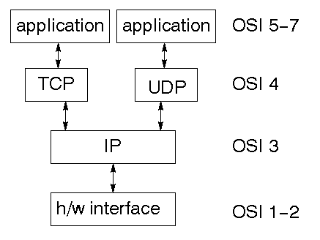

TCP is a connection-oriented protocol; UDP (User Datagram Protocol) is a connectionless protocol.

**IP datagram’s**

The IP layer provides a connectionless and unreliable delivery system. It considers each datagram independently of the others. Any association between datagram must be supplied by the higher layers. The IP layer supplies a checksum that includes its own header. The header includes the source and destination addresses. The IP layer handles routing through an Internet. It is also responsible for breaking up large datagram into smaller ones for transmission and reassembling them at the other end.

**UDP**

UDP is also connectionless and unreliable. What it adds to IP is a checksum for the contents of the datagram and port numbers. These are used to give a client/server model - see later.

**TCP**

TCP supplies logic to give a reliable connection-oriented protocol above IP. It provides a virtual circuit that two processes can use to communicate.

**Internet addresses**

In order to use a service, you must be able to find it. The Internet uses an address scheme for machines so that they can be located. The address is a 32 bit integer which gives the IP address. This encodes a network ID and more addressing. The network ID falls into various classes according to the size of the network address.

**Network address**

Class A uses 8 bits for the network address with 24 bits left over for other addressing. Class B uses 16 bit network addressing. Class C uses 24 bit network addressing and class D uses all 32.

**Subnet address**

Internally, the UNIX network is divided into sub networks. Building 11 is currently on one sub network and uses 10-bit addressing, allowing 1024 different hosts.

**Host address**

8 bits are finally used for host addresses within our subnet. This places a limit of 256 machines that can be on the subnet.

**Total address**

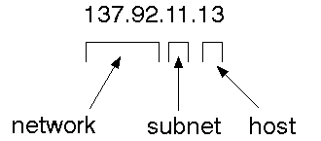

The 32 bit address is usually written as 4 integers separated by dots.

**Port addresses**

A service exists on a host, and is identified by its port. This is a 16 bit number. To send a message to a server, you send it to the port for that service of the host that it is running on. This is not location transparency! Certain of these ports are "well known".

**Sockets**

A socket is a data structure maintained by the system to handle network connections. A socket is created using the call socket. It returns an integer that is like a file descriptor. In fact, under Windows, this handle can be used with Read File and Write File functions.

#include <sys/types.h>

#include <sys/socket.h>

int socket(int family, int type, int protocol);

Here "family" will be AF_INET for IP communications, protocol will be zero, and type will depend on whether TCP or UDP is used. Two processes wishing to communicate over a network create a socket each. These are similar to two ends of a pipe - but the actual pipe does not yet exist.

**JFree Chart**

JFreeChart is a free 100% Java chart library that makes it easy for developers to display professional quality charts in their applications. JFreeChart's extensive feature set includes:

A consistent and well-documented API, supporting a wide range of chart types;

A flexible design that is easy to extend, and targets both server-side and client-side applications;

Support for many output types, including Swing components, image files (including PNG and JPEG), and vector graphics file formats (including PDF, EPS and SVG);

JFreeChart is "open source" or, more specifically, free software. It is distributed under the terms of the GNU Lesser General Public Licence (LGPL), which permits use in proprietary applications.

1. Map Visualizations

Charts showing values that relate to geographical areas. Some examples include: (a) population density in each state of the United States, (b) income per capita for each country in Europe, (c) life expectancy in each country of the world. The tasks in this project include:

Sourcing freely redistributable vector outlines for the countries of the world, states/provinces in particular countries (USA in particular, but also other areas);

Creating an appropriate dataset interface (plus default implementation), a rendered, and integrating this with the existing XYPlot class in JFreeChart;

Testing, documenting, testing some more, documenting some more.

1. Time Series Chart Interactivity

Implement a new (to JFreeChart) feature for interactive time series charts --- to display a separate control that shows a small version of ALL the time series data, with a sliding "view" rectangle that allows you to select the subset of the time series data to display in the main chart.

1. Dashboards

There is currently a lot of interest in dashboard displays. Create a flexible dashboard mechanism that supports a subset of JFreeChart chart types (dials, pies, thermometers, bars, and lines/time series) that can be delivered easily via both Java Web Start and an applet.

1. Property Editors

The property editor mechanism in JFreeChart only handles a small subset of the properties that can be set for charts. Extend (or reimplement) this mechanism to provide greater end-user control over the appearance of the charts.

**J2ME (Java 2 Micro edition):-**

Sun Microsystems defines J2ME as "a highly optimized Java run-time environment targeting a wide range of consumer products, including pagers, cellular phones, screen-phones, digital set-top boxes and car navigation systems." Announced in June 1999 at the JavaOne Developer Conference, J2ME brings the cross-platform functionality of the Java language to smaller devices, allowing mobile wireless devices to share applications. With J2ME, Sun has adapted the Java platform for consumer products that incorporate or are based on small computing devices.

**1. General J2ME architecture**



J2ME uses configurations and profiles to customize the Java Runtime Environment (JRE). As a complete JRE, J2ME is comprised of a configuration, which determines the JVM used, and a profile, which defines the application by adding domain-specific classes. The configuration defines the basic run-time environment as a set of core classes and a specific JVM that run on specific types of devices. We'll discuss configurations in detail in the The profile defines the application; specifically, it adds domain-specific classes to the J2ME configuration to define certain uses for devices. We'll cover profiles in depth in the The following graphic depicts the relationship between the different virtual machines, configurations, and profiles. It also draws a parallel with the J2SE API and its Java virtual machine. While the J2SE virtual machine is generally referred to as a JVM, the J2ME virtual machines, KVM and CVM, are subsets of JVM. Both KVM and CVM can be thought of as a kind of Java virtual machine -- it's just that they are shrunken versions of the J2SE JVM and are specific to J2ME.

**2. Developing J2ME applications**

Introduction In this section, we will go over some considerations you need to keep in mind when developing applications for smaller devices. We'll take a look at the way the compiler is invoked when using J2SE to compile J2ME applications. Finally, we'll explore packaging and deployment and the role pre-verification plays in this process.

**3. Design considerations for small devices**

Developing applications for small devices requires you to keep certain strategies in mind during the design phase. It is best to strategically design an application for a small device before you begin coding. Correcting the code because you failed to consider all of the "gotchas" before developing the application can be a painful process. Here are some design strategies to consider:

* **Keep it simple.** Remove unnecessary features, possibly making those features a separate, secondary application.

* **Smaller is better.** This consideration should be a "no brainer" for all developers. Smaller applications use less memory on the device and require shorter installation times. Consider packaging your Java applications as compressed Java Archive (jar) files.

* **Minimize run-time memory use.** To minimize the amount of memory used at run time, use scalar types in place of object types. Also, do not depend on the garbage collector. You should manage the memory efficiently yourself by setting object references to null when you are finished with them. Another way to reduce run-time memory is to use lazy instantiation, only allocating objects on an as-needed basis. Other ways of reducing overall and peak memory use on small devices are to release resources quickly, reuse objects, and avoid exceptions.

**4. Configurations overview**

The configuration defines the basic run-time environment as a set of core classes and a specific JVM that run on specific types of devices. Currently, two configurations exist for J2ME, though others may be defined in the future:

* **Connected Limited Device Configuration (CLDC)** is used specifically with the KVM for 16-bit or 32-bit devices with limited amounts of memory. This is the configuration (and the virtual machine) used for developing small J2ME applications. Its size limitations make CLDC more interesting and challenging (from a development point of view) than CDC. CLDC is also the configuration that we will use for developing our drawing tool application. An example of a small wireless device running small applications is a Palm hand-held computer.

* **Connected Device Configuration (CDC)** is used with the C virtual machine (CVM) and is used for 32-bit architectures requiring more than 2 MB of memory. An example of such a device is a Net TV box.

**5. J2ME profiles**

**What is a J2ME profile?**

As we mentioned earlier in this tutorial, a profile defines the type of device supported. The Mobile Information Device Profile (MIDP), for example, defines classes for cellular phones. It adds domain-specific classes to the J2ME configuration to define uses for similar devices. Two profiles have been defined for J2ME and are built upon CLDC: KJava and MIDP. Both KJava and MIDP are associated with CLDC and smaller devices. Profiles are built on top of configurations. Because profiles are specific to the size of the device (amount of memory) on which an application runs, certain profiles are associated with certain configurations.

A skeleton profile upon which you can create your own profile, the Foundation Profile, is available for CDC.

**Profile 1: Java**

Java is Sun's proprietary profile and contains the Java API. The Java profile is built on top of the CLDC configuration. The Java virtual machine, KVM, accepts the same byte codes and class file format as the classic J2SE virtual machine. Java contains a Sun-specific API that runs on the Palm OS. The Java API has a great deal in common with the J2SE Abstract Windowing Toolkit (AWT). However, because it is not a standard J2ME package, its main package is com.sun.java. We'll learn more about the KJava API later in this tutorial when we develop some sample applications.

**Profile 2: MIDP**

MIDP is geared toward mobile devices such as cellular phones and pagers. The MIDP, like Java, is built upon CLDC and provides a standard run-time environment that allows new applications and services to be deployed dynamically on end user devices. MIDP is a common, industry-standard profile for mobile devices that is not dependent on a specific vendor. It is a complete and supported foundation for mobile application development. MIDP contains the following packages, the first three of which are core CLDC packages, plus three MIDP-specific packages.

* java.lang

* java.io

* java.util

* javax.microedition.io

* javax.microedition.lcdui

* javax.microedition.midlet

* javax.microedition.rms

**CHAPTER 7**

**MODULE IMPLEMENTATION**

**7.1 MODULES**

* **User Module**
* **Admin Module**
* **Booking Module**
* **Payment Module**

**7.2 MODULE DESCRIPTION**

### **User Module**

### The **User Module** is the primary interface for end-users interacting with the bus reservation system. This module manages user registration, allowing new users to sign up by creating an account with personal credentials, including name, contact details, and preferred payment methods. It handles user authentication through secure login processes, incorporating mechanisms such as password hashing and multi-factor authentication (MFA) to enhance security. Users can manage their profiles, including updating personal information, changing passwords, and setting preferences for communication and notifications. The module also provides access to reservation history, enabling users to track and review past and upcoming bookings, including details like travel dates, bus information, and seat assignments. Additionally, the User Module includes customer support features such as a helpdesk, FAQs, live chat, and ticketing systems, allowing users to resolve issues or get assistance. This module is designed to deliver a user-friendly experience while ensuring the protection of personal and financial data through robust security measures.

Admin Module

The **Admin Module** is a comprehensive toolset designed for system administrators to oversee and manage the bus reservation system’s operations. It includes functionalities for configuring system settings and managing bus schedules, routes, and operational details, ensuring that travel information is accurate and up-to-date. Administrators can add, update, or remove bus routes and schedules, and manage bus details such as capacity and amenities. The module provides tools for user management, allowing administrators to view and edit user profiles, address account issues, and enforce policies such as user roles and permissions. Reservation management features enable admins to monitor all bookings, handle modifications or cancellations, and resolve any conflicts or issues. The Admin Module also incorporates reporting and analytics tools that generate comprehensive reports on system performance, revenue, user activity, and operational metrics. These insights support strategic decision-making and help optimize system operations. Overall, the Admin Module is essential for maintaining the integrity and efficiency of the bus reservation system.

Booking Module

The **Booking Module** is central to the reservation process within the bus reservation system, facilitating the search, selection, and reservation of bus services. It allows users to search for buses based on various criteria, such as departure and arrival locations, travel dates, and times. The module processes search queries and presents users with a list of available buses, including detailed schedules and options. Once a bus is selected, the module displays seat availability and allows users to choose their preferred seats from a visual seat map. The Booking Module manages the reservation process by capturing user details, including passenger names and contact information, and confirming seat allocations. It also handles special requests, such as wheelchair access or additional baggage. After completing the reservation, the module generates a confirmation message or e-ticket, which includes a summary of the booking, travel details, and payment information. The Booking Module ensures a smooth and intuitive booking experience, handling all aspects from search to confirmation efficiently.

Payment Module

The **Payment Module** is responsible for managing financial transactions within the bus reservation system, ensuring that payments are processed securely and accurately. It integrates with various payment gateways and processors to handle transactions through credit cards, debit cards, and other online payment methods. The module validates payment information to prevent errors and fraudulent activities, using encryption and secure communication protocols to protect sensitive data. It manages transaction statuses, including pending, completed, or failed transactions, and provides mechanisms for handling payment disputes or refunds. The Payment Module generates and sends receipts or payment confirmations to users, serving as proof of transaction and providing details of the payment process. It also supports features such as transaction history tracking and reconciliation, ensuring that financial records are accurate and up-to-date. The module is designed to facilitate a seamless payment experience for users while maintaining high standards of security and reliability.

**CHAPTER 8**

### SYSTEM TESTING

The testing is a critical phase in the software development life cycle, aimed at uncovering errors and ensuring that a software system functions as intended. This process involves systematically examining components, sub-assemblies, and the complete system to identify faults or weaknesses. The primary goal is to verify that the software meets specified requirements and user expectations while avoiding unacceptable failures. Various types of tests are employed, each addressing specific testing requirements. These may include functional testing to assess whether the system performs its intended functions correctly, performance testing to evaluate its responsiveness and scalability, and security testing to identify vulnerabilities. Through comprehensive testing, developers and quality assurance teams strive to deliver a reliable and robust software product that meets or exceeds user expectations.

**TYPES OF TESTS**

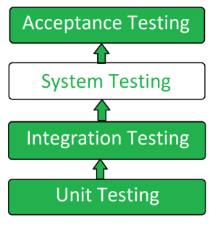

**Unit Testing:**

Unit testing is the first level of software testing where individual units or components of a system are tested in isolation. The main purpose is to ensure that each unit functions as expected. Units are typically the smallest testable parts of a software, such as functions, methods, or classes. Test cases are designed to validate the correctness of each unit's behavior, covering various scenarios and edge cases. Unit testing is crucial for identifying and fixing bugs early in the development process, promoting code reliability, and facilitating code maintenance.

**Integration Testing:**

Integration testing focuses on testing the interactions between different units or modules of a system to ensure they work together as intended. The purpose is to detect interface defects and verify the correct flow of data between integrated components. Integration tests can be incremental, where units are combined gradually, or they can be comprehensive, testing the entire system after all components have been integrated. This testing phase helps uncover issues related to data communication, dependencies, and interface mismatches, ensuring a smooth collaboration between individual units.

**System Testing:**

System testing involves testing the complete and integrated software system as a whole. It verifies that the system meets the specified requirements and functions according to its design. This testing phase evaluates the system's behavior, performance, security, and overall functionality. System tests cover a broad range of scenarios, including normal operations, boundary conditions, and error conditions. It ensures that all components work together seamlessly and that the system meets the end-users' expectations. System testing is critical for identifying any issues that may arise from the interactions between different subsystems.

**Acceptance Testing:**

Acceptance testing is the final phase of testing before the software is released to users. The primary objective is to validate that the system meets the specified business requirements and is acceptable for delivery. Acceptance testing can be categorized into two main types: User Acceptance Testing (UAT) and Business Acceptance Testing (BAT). UAT involves end-users testing the software to ensure it aligns with their needs, while BAT involves business stakeholders validating that the system satisfies the predefined business criteria. Successful completion of acceptance testing provides confidence to stakeholders that the software is ready for deployment.

**Chapter 9**

**Screen Short**

**Main Form**

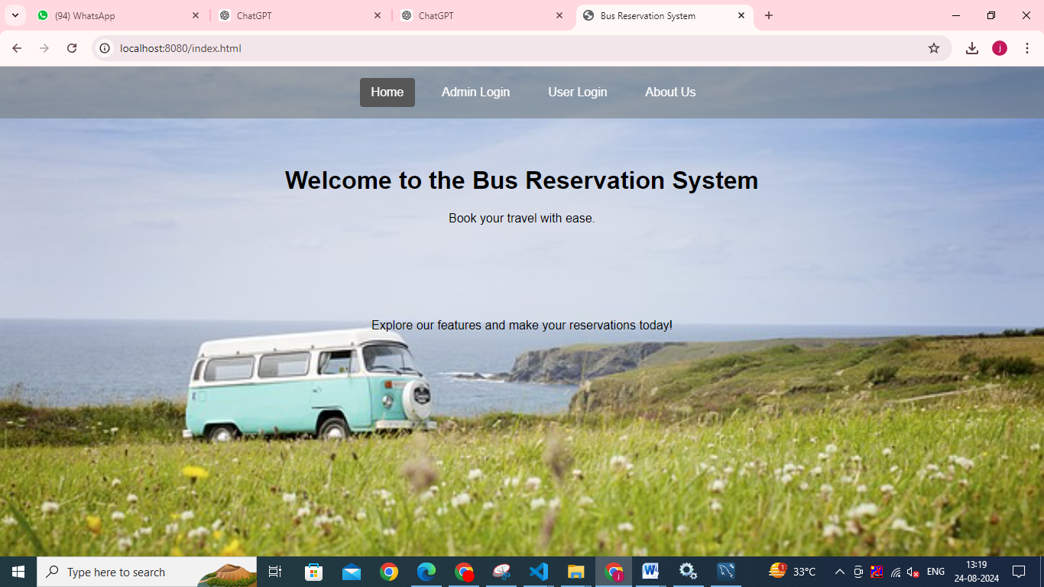

**User Login**

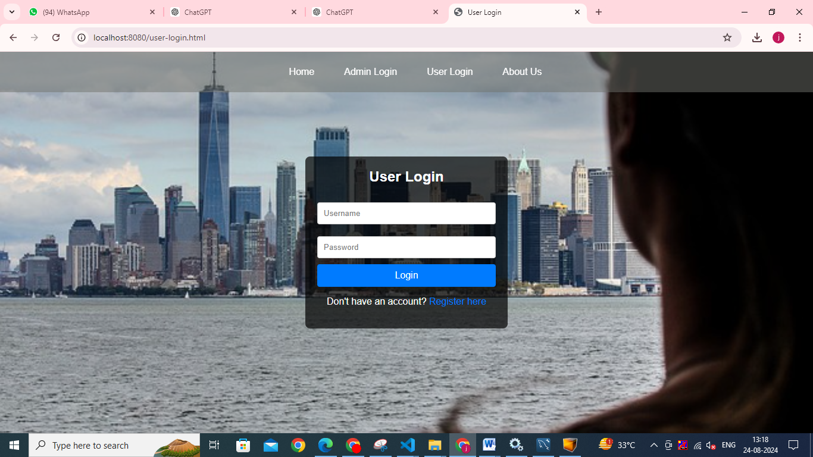

**Admin Login**

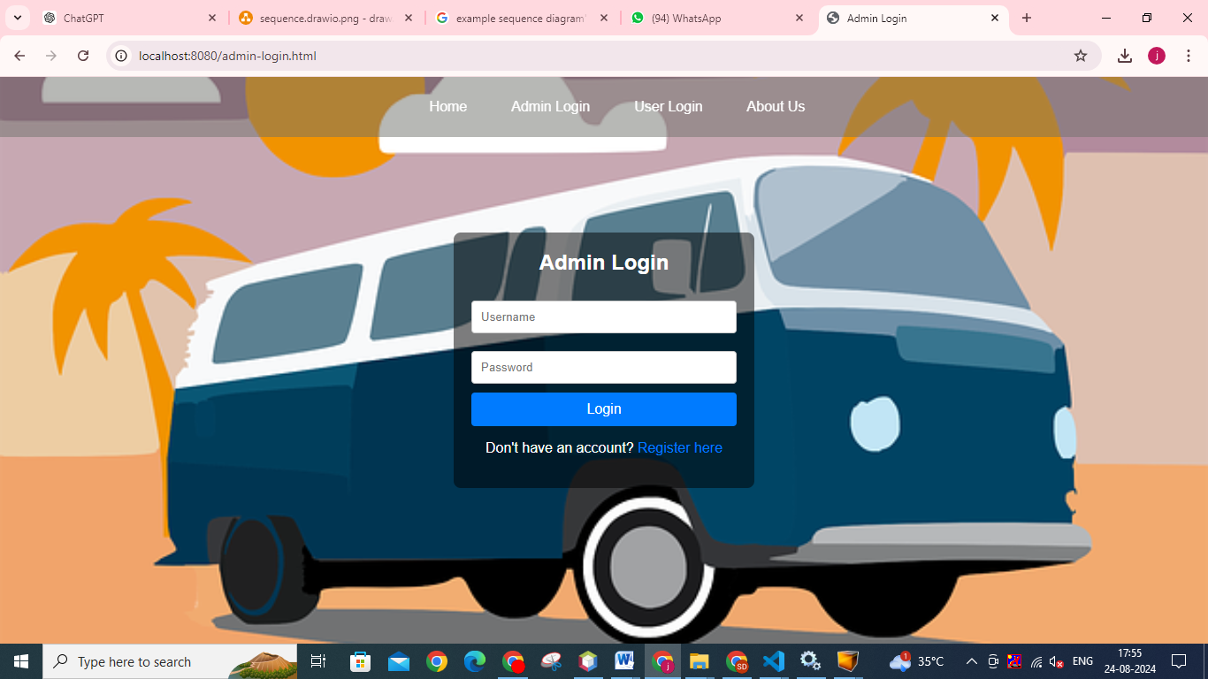

**Add Bus**

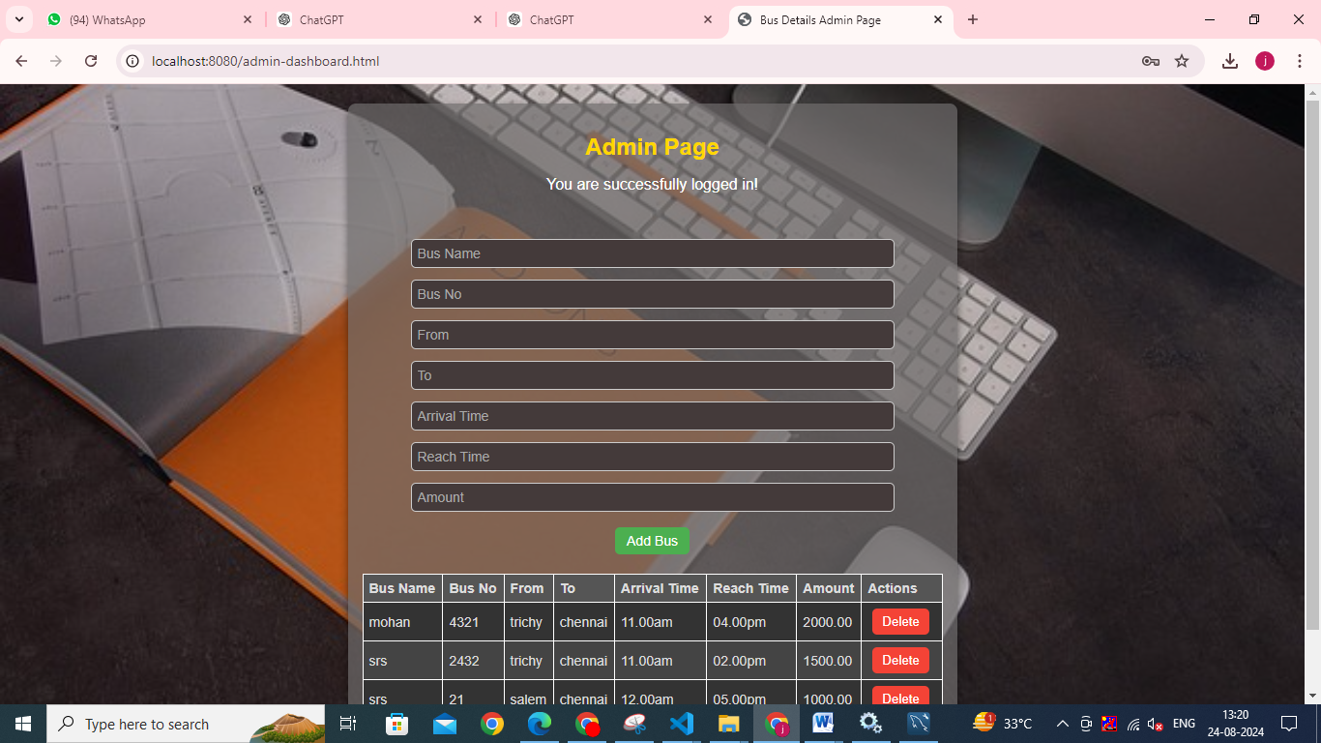

**Bus Booking**

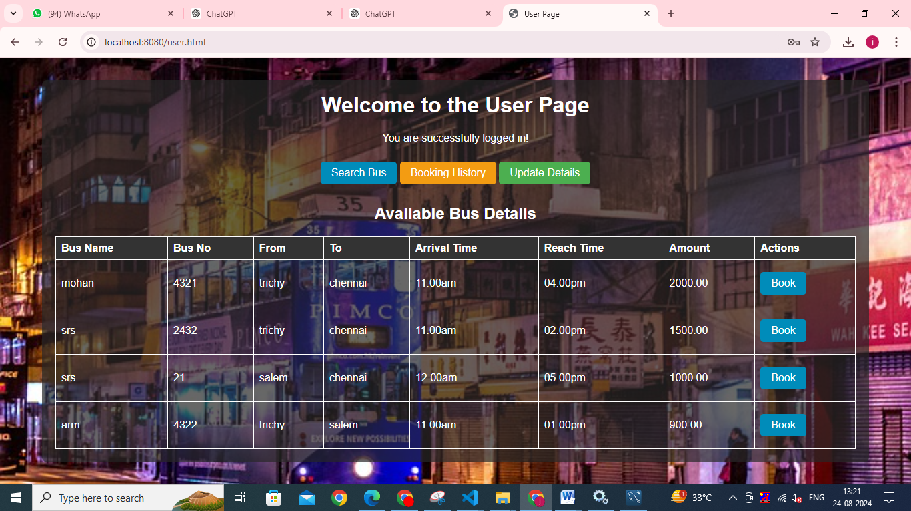

**Payment**

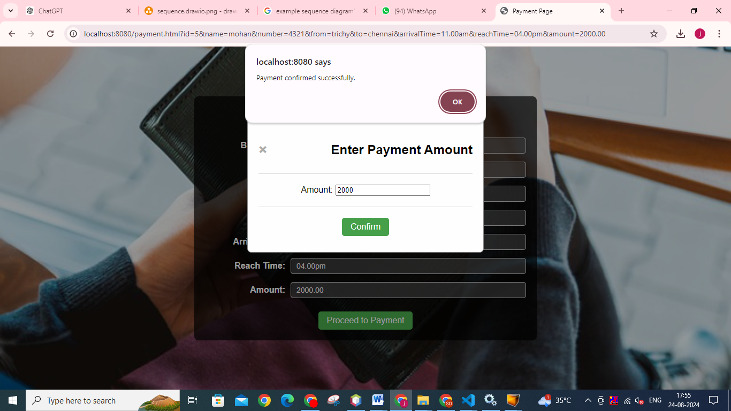

**Booking History**

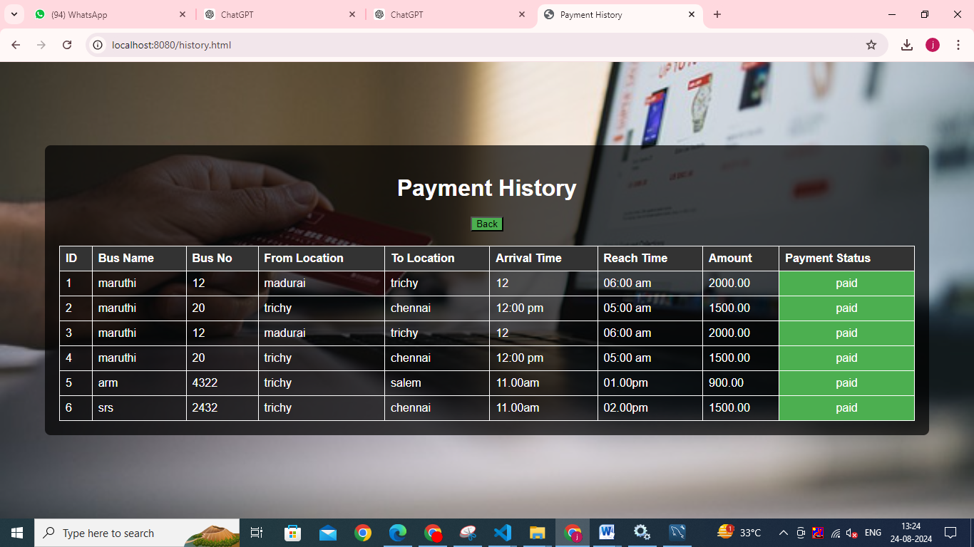

**CHAPTER 10**

**CONCLUSION & FUTURE ENHANCEMENT**

### Conclusion

The development and implementation of a comprehensive bus reservation system encompass several critical modules, each tailored to address specific aspects of user interaction, administrative oversight, booking management, and payment processing. The **User Module** serves as the primary interface for customers, providing essential functionalities for account management, reservation history, and support. It ensures a seamless user experience by facilitating secure registration, login, and profile management while addressing user queries and issues. The **Admin Module**, on the other hand, empowers system administrators with tools to configure settings, manage bus schedules, oversee reservations, and generate detailed reports. This module is crucial for maintaining the system’s operational efficiency and ensuring accurate and up-to-date travel information.

The **Booking Module** is central to the core functionality of the reservation system. It enables users to search for buses, select seats, and make reservations with ease. By managing the booking process from search to confirmation, this module ensures a smooth and user-friendly experience, accommodating user preferences and special requests. Complementing this is the **Payment Module**, which handles all financial transactions, ensuring secure payment processing and accurate transaction management. By integrating with various payment gateways, this module facilitates a secure and efficient payment experience while generating receipts and handling refunds as necessary.

Together, these modules form the backbone of a robust bus reservation system, addressing both user and administrative needs and ensuring a seamless, secure, and efficient booking process. The system’s design and implementation reflect a focus on user experience, operational efficiency, and financial integrity, providing a reliable solution for managing bus reservations.

### Future Enhancements

While the current bus reservation system provides a solid foundation, several enhancements could further improve its functionality, user experience, and operational efficiency. These future enhancements can be categorized into technological advancements, user experience improvements, and expanded functionalities.

**1. Technological Advancements:**

* **Artificial Intelligence (AI) and Machine Learning (ML):** Integrating AI and ML algorithms can enhance the system’s capabilities, such as predicting user preferences based on historical data, optimizing seat allocation, and offering personalized travel recommendations. AI-powered chatbots could also provide 24/7 customer support, handling common queries and issues with greater efficiency.
* **Blockchain Technology:** Implementing blockchain can enhance transaction security and transparency. Smart contracts could automate reservation and payment processes, reducing the risk of fraud and ensuring immutable records of transactions.
* **Cloud Integration:** Leveraging cloud technology can improve system scalability, reliability, and performance. Cloud-based solutions can offer better data storage, enhanced security, and the ability to handle peak traffic more effectively.

**2. User Experience Improvements:**

* **Mobile App Enhancements:** Developing a dedicated mobile app with advanced features such as real-time bus tracking, notifications, and offline access can significantly enhance user convenience. Features like push notifications for reservation updates, delays, or promotions can keep users informed and engaged.
* **User Interface (UI) and User Experience (UX) Design:** Continuous improvement of the UI/UX design can lead to a more intuitive and engaging user experience. Incorporating user feedback into design iterations can help address pain points and improve overall satisfaction.
* **Accessibility Features:** Enhancing accessibility features, such as voice commands, screen readers, and customizable interfaces, can ensure that the system is usable by individuals with disabilities, providing a more inclusive experience.

**3. Expanded Functionalities:**

* **Dynamic Pricing and Offers:** Implementing dynamic pricing models can optimize revenue and offer competitive pricing based on demand, seasonality, and booking patterns. Additionally, integrating promotional offers, loyalty programs, and discounts can attract and retain customers.
* **Multi-Language and Multi-Currency Support:** Expanding the system to support multiple languages and currencies can make it more accessible to a global audience, accommodating users from different regions and facilitating international transactions.
* **Integration with Other Travel Services:** Integrating with other travel services, such as hotels and car rentals, can provide a comprehensive travel solution. Offering bundled packages or partnerships with other service providers can enhance the overall user experience and increase system adoption.

**4. Advanced Reporting and Analytics:**

* **Enhanced Reporting Tools:** Developing more advanced reporting tools can provide deeper insights into user behavior, booking trends, and financial performance. Customizable dashboards and real-time analytics can aid administrators in making data-driven decisions and identifying areas for improvement.
* **Predictive Analytics:** Utilizing predictive analytics can help forecast future trends, such as peak booking periods and user preferences. This information can inform strategic planning, resource allocation, and marketing efforts.

In conclusion, the bus reservation system has established a strong foundation with its current modules, addressing essential user and administrative needs. Future enhancements, driven by technological advancements, user experience improvements, and expanded functionalities, can further elevate the system’s capabilities, ensuring it remains competitive and responsive to evolving market demands. By incorporating these advancements, the system can provide an even more efficient, user-friendly, and comprehensive solution for managing bus reservations and enhancing the overall travel experience.

**REFERENCE**

* M. Kaur A/P Narjan Singh, "A Study and Development of an Online Bus Ticketing System," June 2007.
* A. K. Ibrahim and A. B. Ta'a, "Mobile-Based Bus Ticketing System in Iraq," *European Journal of Computer Science and Information Technology,* November 2015.
* M. Oloyede, S. M. Alaya, and A. Adewole, "Development of an Online Bus Ticket Reservation System for a Transportation Service in Nigeria," *Computer Engineering and Intelligent Systems,* 2014.
* L. A. Yazid and R. Samsudin, "Bus Ticket Booking Mobile Application," *UTM Computing Proceedings Innovation in Computing Technology and Applications,* 2017.
* N. I. Cosmas, E. C. Ajere, and U. G. Agomuo, "Online Bus Ticket Reservation System," *IIARD International Journal of Computer Science and Statistics,* 2015.
* M. C. Ferreira, H. Nóvoa, T. G. Dias, and J. F. E. Cunha, "A Proposal for a Public Transport Ticketing Solution Based on Customers’ Mobile Devices," *EWGT2013 – 16th Meeting of the Euro Working Group on Transportation,* 2013.
* F. Fitriani, L. A. Abdillah, and D. Erlansyah, "Android-Based Bus Ticket Reservation Application," *The 4th ICIBA 2015, International Conference on Information Technology and Engineering Application Palembang-Indonesia,* February 20-21, 2015.
* N. Patil and A. K. Adarsh, "Android Bus Ticketing System," *International Journal of Electrical, Electronics and Data Communication,* Issue 10, October 2017.
* S. Sandiwarno, "Design Model of Bus Ticketing by Seating at PT. XYZ," *International Journal of Computer Science and Mobile Computing,* March 2018, pp. 1-7.
* S. Subbulakshmi and K. Jaichithra, "Android Application for Integrated Travel Transport System," *IOSR Journal of Mobile Computing & Application (IOSR-JMCA),* September-October 2016.